- ReactJS HandsOn

Create a React Application named “cricketapp” with the following components:
- ListofPlayers
- Declare an array with 11 players and store details of their names and scores using the map feature of ES6

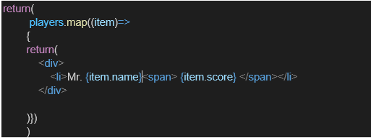

- Filter the players with scores below 70 using arrow functions of ES6.

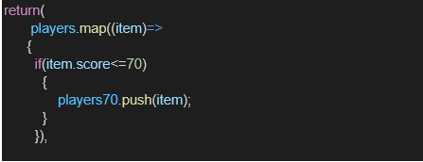

- IndianPlayers

  - Display the Odd Team Player and Even Team players using the Destructuring features of ES6
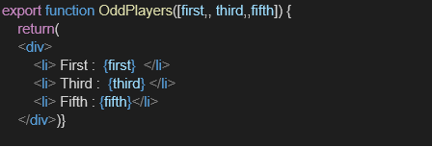

  - Declare two arrays T20players and RanjiTrophy players and merge the two arrays and display them using the Merge feature of ES6
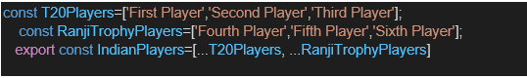
Display these two components in the same home page using a simple if else in the flag variable.

Project Structure:

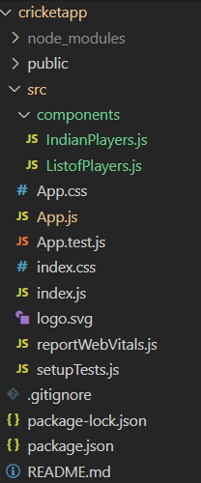

IndianPlayer.js

import React from 'react';

export function OddPlayers({ team }) {
const [first, , third, , fifth] = team;
return (
<ul>
<li>First: {first}</li>
<li>Third: {third}</li>
<li>Fifth: {fifth}</li>
</ul>
);
}

export function EvenPlayers({ team }) {
const [, second, , fourth, , sixth] = team;
return (
<ul>
<li>Second: {second}</li>
<li>Fourth: {fourth}</li>
<li>Sixth: {sixth}</li>
</ul>
);
}

export function ListofIndianPlayers({ IndianPlayers }) {
return (
<ul>
{IndianPlayers.map((player, index) => (
<li key={index}>{player}</li>
))}
</ul>
);
}

ListofPlayers.js

import React from 'react';

function ListofPlayers({ players }) {
return (
<div>
<ul>
{players.map((item, index) => (
<li key={index}>
Mr. {item.name} <span>({item.score})</span>
</li>
))}
</ul>
</div>
);
}

export function ScoreBelow70({ players }) {
const filteredPlayers = players.filter(item => item.score < 70);
return (
<div>
<ul>
{filteredPlayers.map((item, index) => (
<li key={index}>
Mr. {item.name} <span>({item.score})</span>
</li>
))}
</ul>
</div>
);
}

export default ListofPlayers;

App.js

import React from 'react';
import ListofPlayers, { ScoreBelow70 } from './components/ListofPlayers';
import { OddPlayers, EvenPlayers, ListofIndianPlayers } from './components/IndianPlayers';

function App() {
const flag = false; // can be toggled

const players = [
{ name: 'Kohli', score: 80 },
{ name: 'Rohit', score: 60 },
{ name: 'Rahul', score: 90 },
{ name: 'Shreyas', score: 65 },
{ name: 'Hardik', score: 70 },
{ name: 'Jadeja', score: 55 },
{ name: 'Pant', score: 45 },
{ name: 'Bumrah', score: 72 },
{ name: 'Shami', score: 50 },
{ name: 'Ashwin', score: 78 },
{ name: 'Surya', score: 67 }
];

const T20Players = ['First Player', 'Second Player', 'Third Player'];
const RanjiTrophyPlayers = ['Fourth Player', 'Fifth Player', 'Sixth Player'];
const IndianTeam = [...T20Players, ...RanjiTrophyPlayers];

return (
<div className="App">
{flag ? (
<div>
<h1>List of Players:</h1>
<ListofPlayers players={players} />

<h1>List of Players having Scores Less than 70</h1>
<ScoreBelow70 players={players} />
</div>
) : (
<div>
<h1>Indian Team</h1>
<h3>Odd Players</h3>
<OddPlayers team={IndianTeam} />

<h3>Even Players</h3>
<EvenPlayers team={IndianTeam} />

<h3>List of Indian Players Merged</h3>
<ListofIndianPlayers IndianPlayers={IndianTeam} />
</div>
)}
</div>
);
}

export default App;

Output:

When flag = true

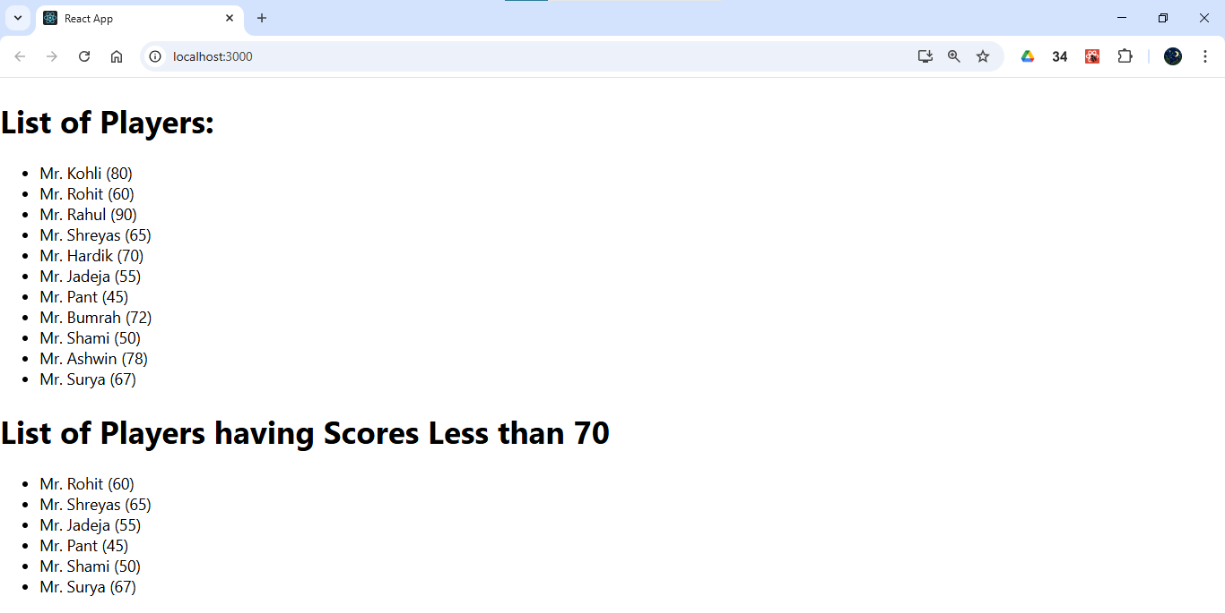

When flag = false

